Social, Emotional, and Academic Development (SEAD)
Lesson Plan for Mathematics

GRADE LEVEL/COURSE AND MATH STANDARD(S)
Grade 5
5.NBT.B.5: Fluently multiply multi-digit whole numbers using the standard algorithm.

LESSON OBJECTIVE/GOAL
- Student objective: I can explain my thinking and respond to the mathematical thinking of others.

LANGUAGE OBJECTIVE(S)/GOAL(S)
- Student objective: I can orally explain my mathematical approach in solving a multiplication problem.

INTRODUCTION
The task was adapted from Illustrative Mathematics Grade 5, Unit 8, Lesson 3 and utilizes the lesson planning template from Stride 3: A Pathway to Equitable Math Instruction: Creating Conditions to Thrive (pages 13–14).

The lesson is intended to:
- Promote student agency by establishing the teacher as a facilitator, posing the problems, and supporting students to select their own approach to represent multi-digit multiplication
- Create opportunities to strengthen number sense and procedural fluency for multiplying multi-digit whole numbers
- Building students’ ownership allowing them to select their approach to solve fo a product based on flexibility and efficiency
- Foster students’ meta-awareness as they identify, compare, and contrast different mathematical approaches
SEAD THEME

 | Identity
X | Discourse
X | Agency
 | Belonging

SMP(S) TO SUPPORT THE SEAD THEME

 | SMP 1: Make sense of problems and persevere in solving them.
 | SMP 2: Reason abstractly and quantitatively.
X | SMP 3: Construct viable arguments and critique the reasoning of others.
 | SMP 4: Model with mathematics.
 | SMP 5: Use appropriate tools strategically.
 | SMP 6: Attend to precision.
X | SMP 7: Look for and make use of structure.
 | SMP 8: Look for and express regularity in repeated reasoning.

STEPS
- Teacher presents learning objectives and SMP of focus using SMP math posters.

- Teacher facilitates a number talk that has opportunities for students to flexibly solve for the product mentally as the factor increases.
  - Find the value of each expression mentally:
    - 230 x 10
    - 230 x 12
    - 230 x 15
    - 232 x 15
Teacher Questions to facilitate the discussion:
- “Does this match what you were thinking?”
- “Can we name and define this strategy?”
- “Are there helpful patterns in this number string?”
- “Are there any problems that we solved in the same way/different?”
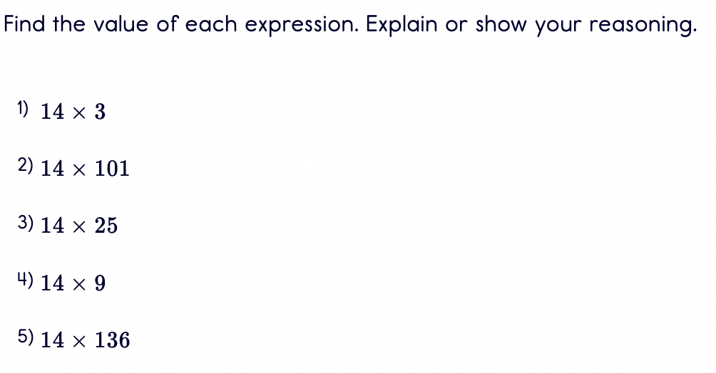
- “Which problem was the most challenging to solve mentally?”

- Teacher launches Task 1: Choose a Multiplication Strategy
  - Say: “Look at the problems. Choose 2 problems you would solve using a different strategy.” Students will then describe their approach in solving the problem to a partner.
  - Allow independent work time to solve the value of each expression. (5 - 10 mins) Then, allow time for partner work. (8 - 10 mins).
  - Circulate the classroom and select 2 students that solved the same problem, but using a different approach.
  - Lead a discussion using the strategy: Compare and Connect in which students share their mathematical approach to solving a problem.
Teacher questions to facilitate the discussion:
    - “What is the same/different between these strategies?”
    - “Why did the different approaches lead to the same outcome?”
    - “Are there any benefits or drawbacks to one strategy compared to the other?”

- Teacher launches Task 2: Compare Strategies
  - Say: “In this task you will first solve for the product independently. Then, you will have some time to explain your mathematical approach and compare it to the others in your small group.”
  - Present sentence stems for students to share their mathematical approaches and make connections.
    - I solved ______ by ________.
    - My strategy for the equation _______ was _______.
    - Something similar that I did was ______.
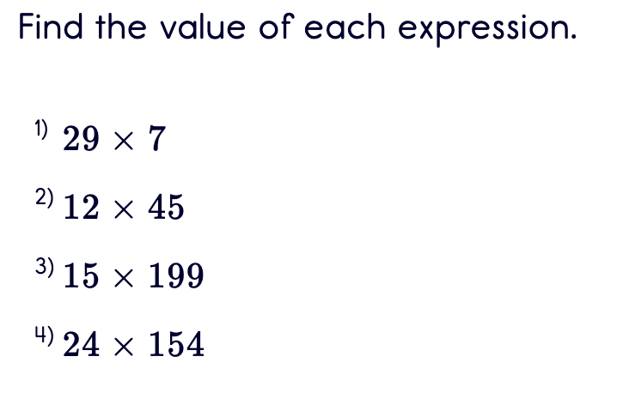
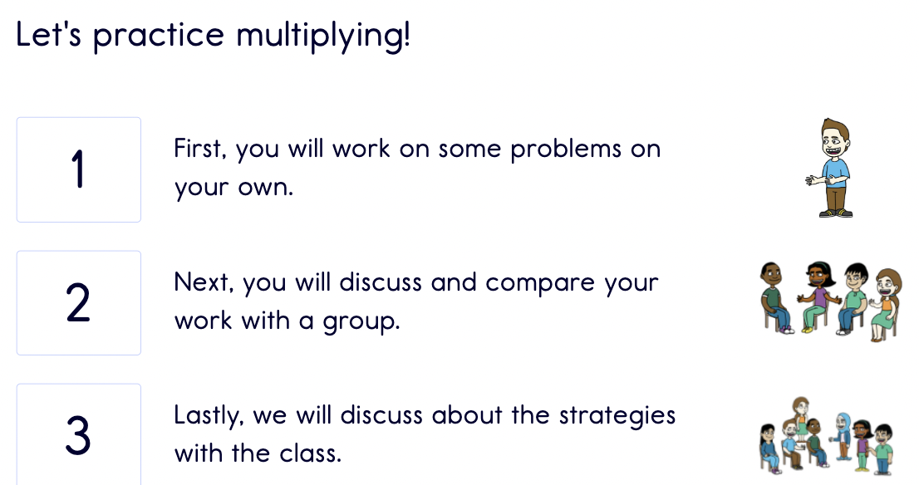
    - We both _______.

- Teacher synthesizes the lesson by asking students to reflect on multiplication.
  - Describe a challenge with multiplication.
  - Describe your approach to multiplication. Does it always work? If not, why?
  - Describe something new or interesting you learned about multiplication.

SUMMARY/REFLECTION OF LESSON

In this lesson students had the opportunity to multiply using their own strategy, as I set myself as a facilitator allowing students to select their own approach to multiplication. Students began to discuss possible strategies in our number talk. Students then continued to use these strategies as they worked out self selected problems in their workbooks.
I loved that there were a variety of problems --ones with single digit factors and others with multiple digit factors. Students were encouraged to use different strategies within their work Some students used strategies like repeated addition which allowed us to have a discussion about efficiency of strategies. I intentionally planned out student sharing, hearing from students who chose a variety of strategies, to allow for this conversation to happen.

At the end, in the student reflection, they were able to describe challenges, their approach to multiplication, and something interesting they learned about multiplication. One of my students shared that multiplication used to be difficult but now they felt more confident due to the fact that they had many strategies to choose from. This lesson was one where students truly had a sense of belonging in their strategy and agency in their ability to choose their own mathematical approach.

